**Task 3: Create and Configure a Virtual Private Cloud (VPC) with Subnets**

**Objective :-**

* To understand how cloud networking works by creating a Virtual Private Cloud (VPC) with public and private subnets, and configuring controlled internet access.
* This task demonstrates the foundation of secure cloud architecture, focusing on network isolation, routing, and resource protection.

**Steps to Implement :-**

1. Create a VPC

* Go to the VPC Dashboard in your cloud provider (e.g., AWS).
* Click Create VPC → Select VPC only.
* Provide:
  + Name: Task-3
  + IPv4 CIDR block: 10.0.0.0/16
* 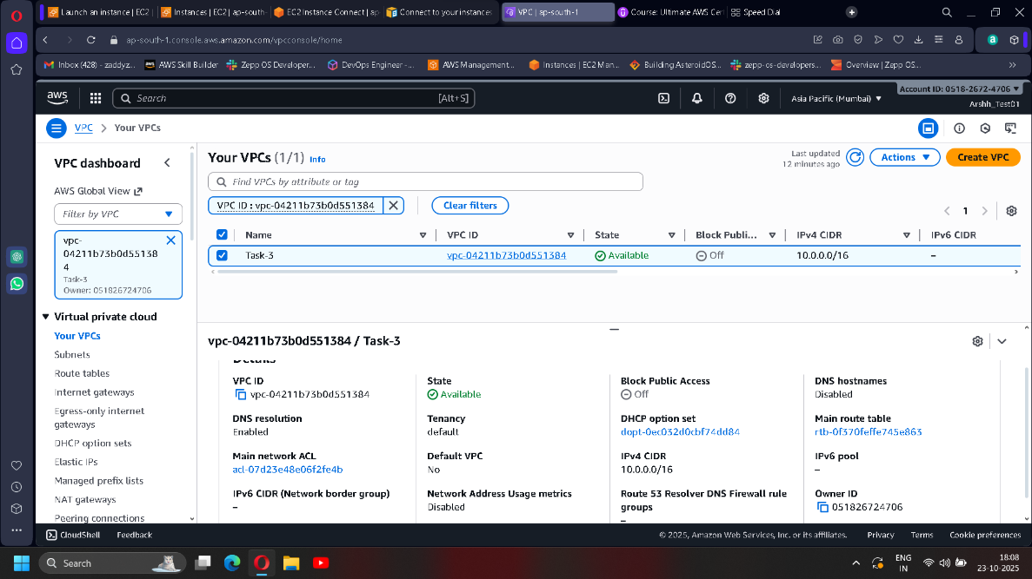Click Create VPC.

**2. Create Subnets :-**

a) Public Subnet

* Go to Subnets → Create Subnet.
* Choose your VPC.
* Enter details:
  + Subnet name: Task-3-Subnet-Public
  + Availability Zone: Select one (e.g., ap-south-1a)
  + CIDR block: 10.0.1.0/24
* 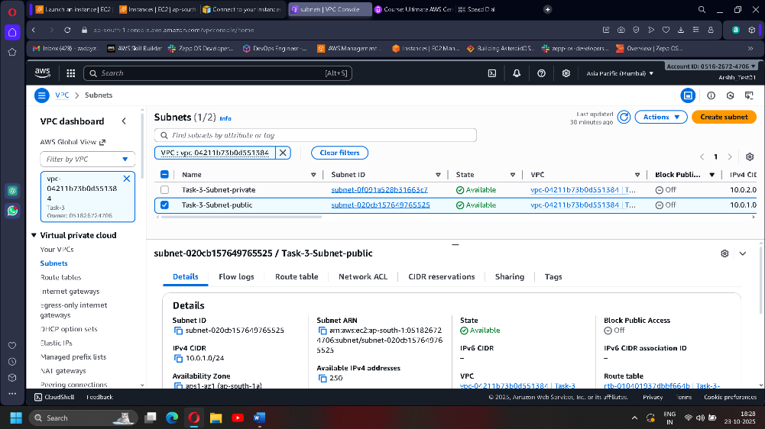Click Create Subnet.

b) Private Subnet

* Repeat the process for:
  + Subnet name: Task-3-Subnet-Private
  + 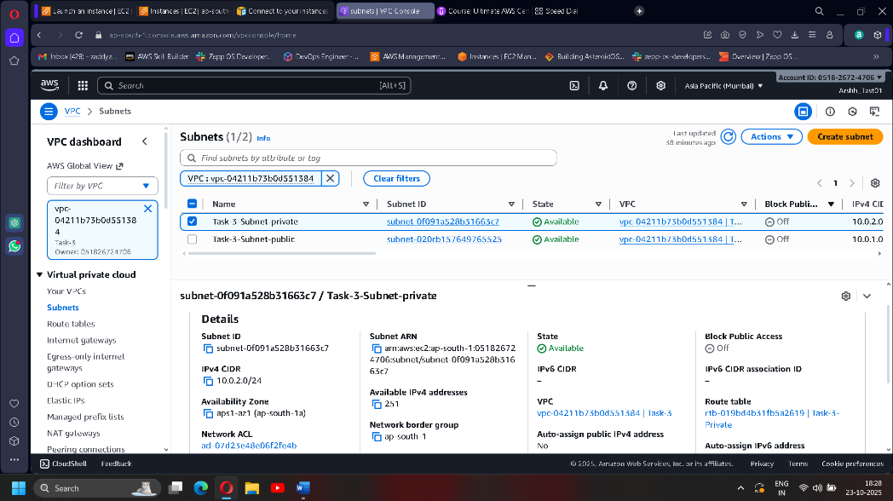CIDR block: 10.0.2.0/24

**3. Create and Attach an Internet Gateway :-**

* Navigate to Internet Gateways → Create Internet Gateway.
* Name it Task-3-Gateway and click Create.
* 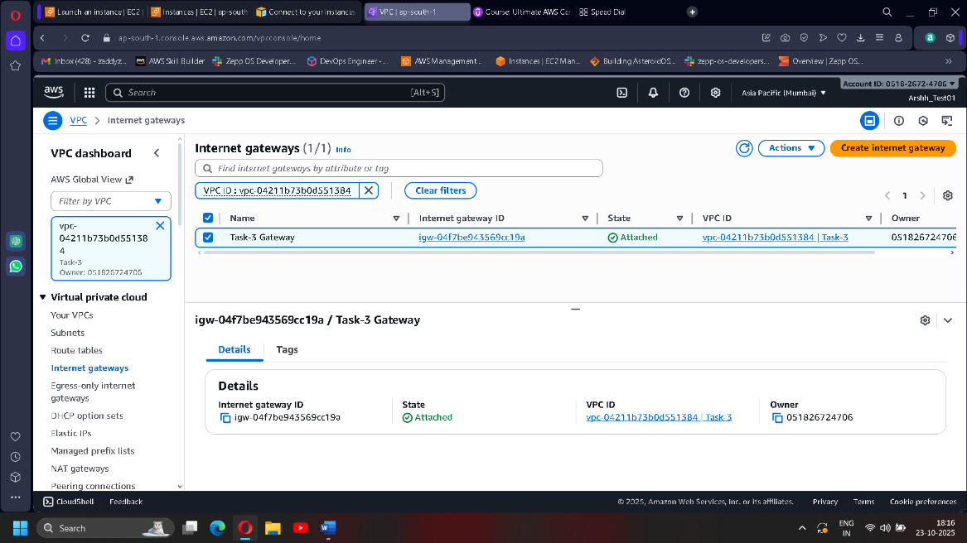Attach it to your VPC using Actions → Attach to VPC.

**4. Configure Route Tables :-**

a) Public Route Table

* Go to Route Tables → Create Route Table.
* Name: Task-3-Public, associate it with your VPC.
* Under Routes, add:
  + Destination: 0.0.0.0/0
  + Target: Internet Gateway (MyIGW)
* 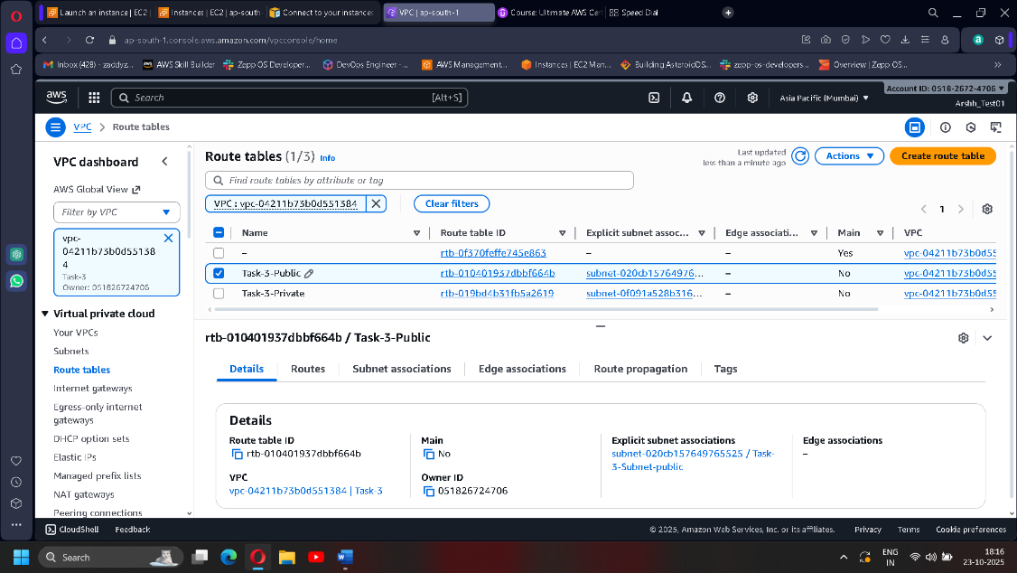Under Subnet Associations, associate Public-Subnet.

b) Private Route Table

* Create another route table named Task-3-Private
* Do not add an internet route.
* 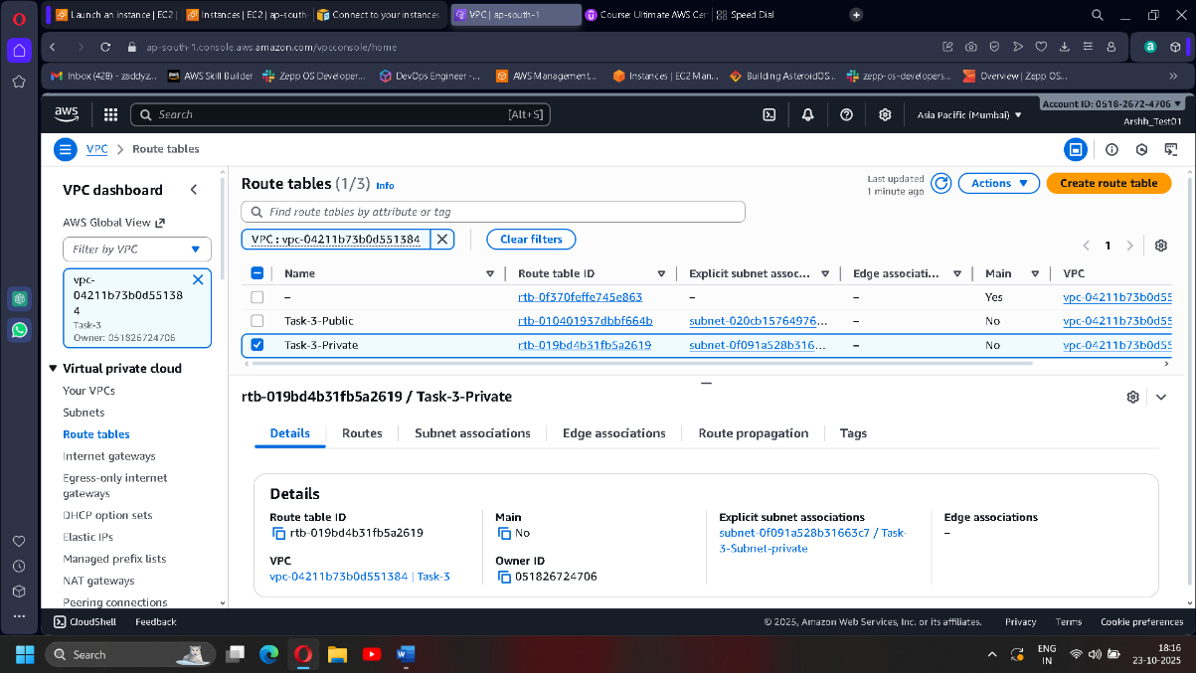Associate it with Private-Subnet.

**4. Launch EC2 Instances**

* **Public EC2 Instance:**
  + Launch in Public-Subnet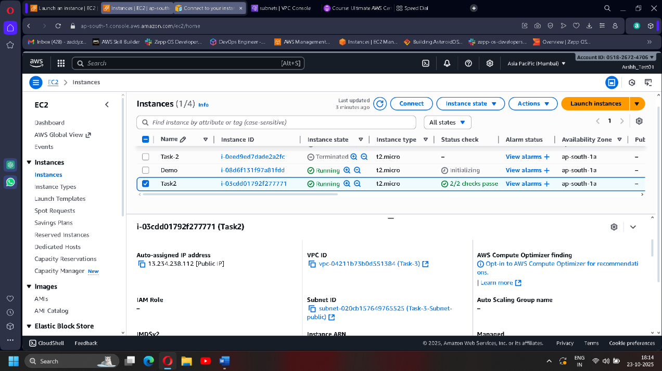
* **Private EC2 Instance:**
  + Launch in Private-Subnet

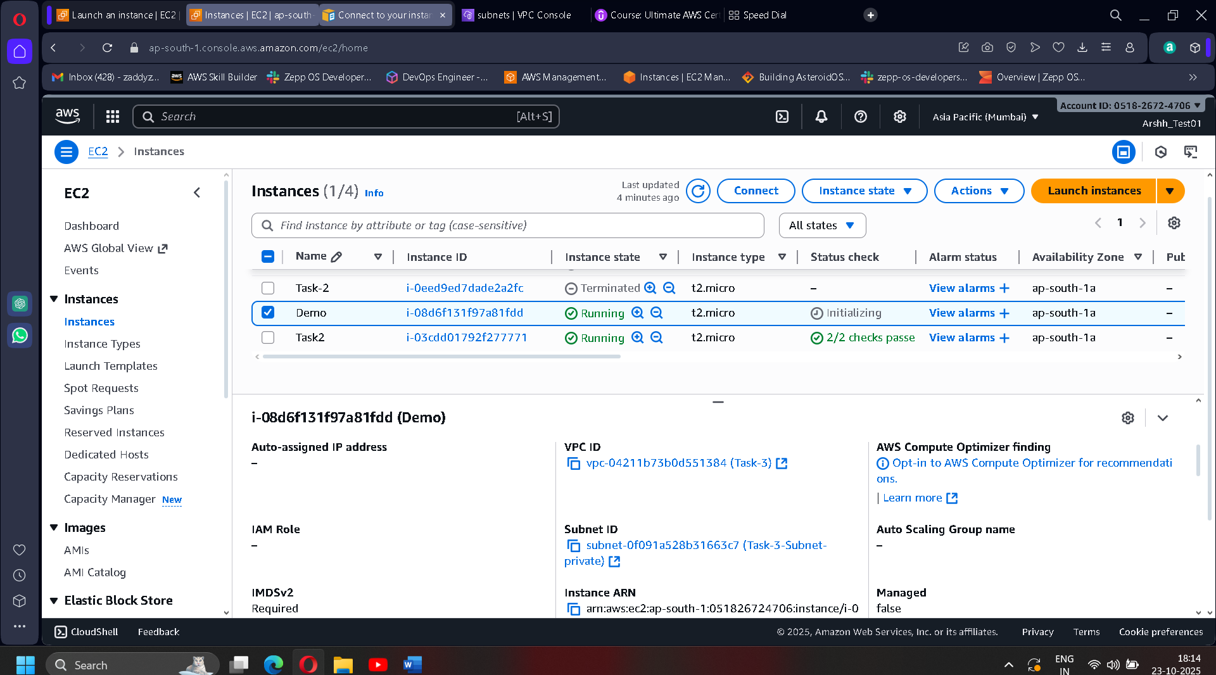

**5. Test Connectivity**

* 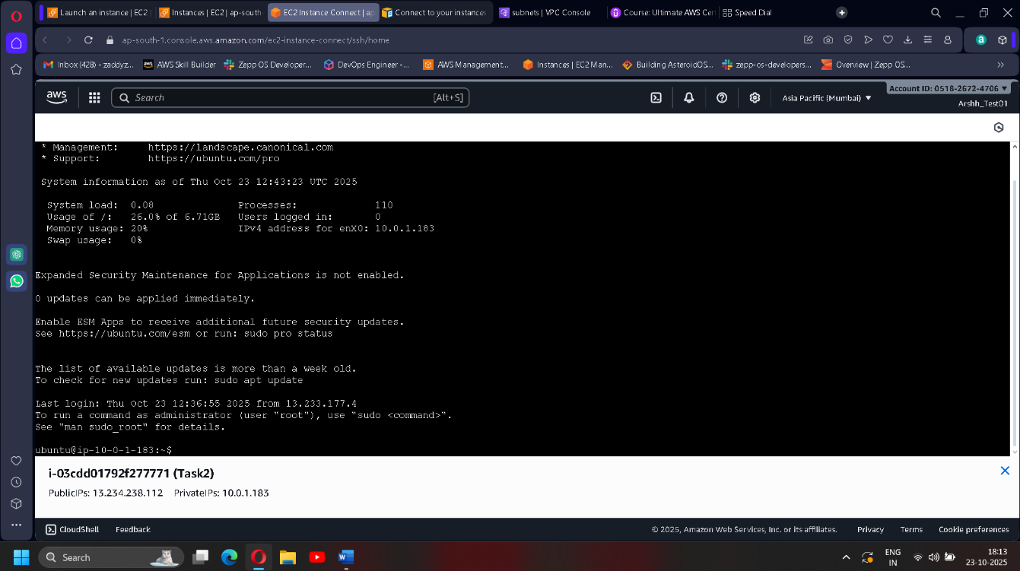SSH into your **Public EC2** (using its public IP).

